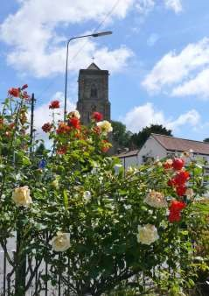

The Newsletter for Middleton on the Wolds

Issue No 17

July 2020

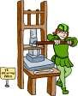
NEXT COPY DATE
14th July

Please send in your contributions to middletonflyer@yahoo.com by the end of the copy day. If I don’t acknowledge them please get in touch to make sure they have arrived.
We are very pleased to be able to have the full number of hard copies produced this month and grateful for the young people who deliver to your homes. Full government guidelines will be followed to equip them with whatever safety equipment is required.
I am always happy to receive the regular entries for The Messenger but welcome anything from new contributors too. As sporting clubs and other organisations are starting up again, why not write a short piece letting people know how you will be managing the safety measures and encouraging others to join?
I know there has been quite a lot of baking going on during lock down and wonder if anyone has discovered tasty recipes that they would like to share. On the quiz page, would you like a change from the sudoku and dingbats? Any ideas?
Finally an apology: there isn’t room in this month’s printed Messenger for the list of group contacts so, if you need these details, please look at an old edition or check on the Parish Council website version.
Lyn
4 The Paddocks 219500
you want to share then send an email to middletonflyer@yahoo.com
Remember, we can’t respond unless we receive your message.

For details of how to advertise in The Middleton Messenger please contact Tina on 03177 217242 or middletonflyer@yahoo.com

editorial
And so, we race into summer. Sun beating down from cloudless skies. The gentle buzz of bees bumbling from flower to flower. Well that was last month, anyway! After the unbroken sunshine of May, June started with some much-needed rain and the whole place is a lot greener. It might not be as conducive to leisure as a heat wave but at least it saves us from having to ‘water up’! The way things
are growing just now it’s a shame there won’t be a produce show, this year; there may well be some record breakers in local gardens.
It’s been a while (no, not ‘forever’!) but the village is opening up even more.
The hard tennis court is getting a lot more use than it ever has as players take (or, at least, ‘took’) advantage of the glorious weather and the advice that we no longer have to limit our exercise to only one hour a day. And more services are now available. We can get takeaways from the Robin Hood and from Mable; buy fresh fruit and veg from the stall on Goodmanham Road; and the chip van is back. These are all great amenities for the village, but they can only keep going if we support them so please try to use them at least now and then even if you don’t want to regularly.
We must all give a big thankyou to Andrew, Peter and everybody else who has been working so hard on the railway embankment. The foxgloves are looking splendid and there is much more light up there. It’s another example of how we can make Middleton a little better by actually doing something rather than waiting for it to be done. If we add this to the other side of the embankment, the grass verge along Beverley Road, and way the public footpath along the top has been cut back then we have some excellent, connected walks around Middleton. It is now up to us to keep them clear by using them as much as possible.
And finally, the Thursday night clapping for NHS workers has been wound up. For the last couple of months people in Middleton, as in the rest of the country, have come together as a community to show support for those who are looking after us through lockdown. Let’s try not to lose that community spirit and let’s also remember all those who are still working in difficult circumstances to keep society going. So don’t forget the bin men, postal workers, bus drivers, teachers and teaching assistants, delivery drivers and shop workers (if I’ve forgotten anyone I apologise). At the very least we can be polite to them and try to make their jobs as stress free as possible.
Stay safe.
Cheers,

Mike
If you have any ideas, comments or complaints (especially complaints)
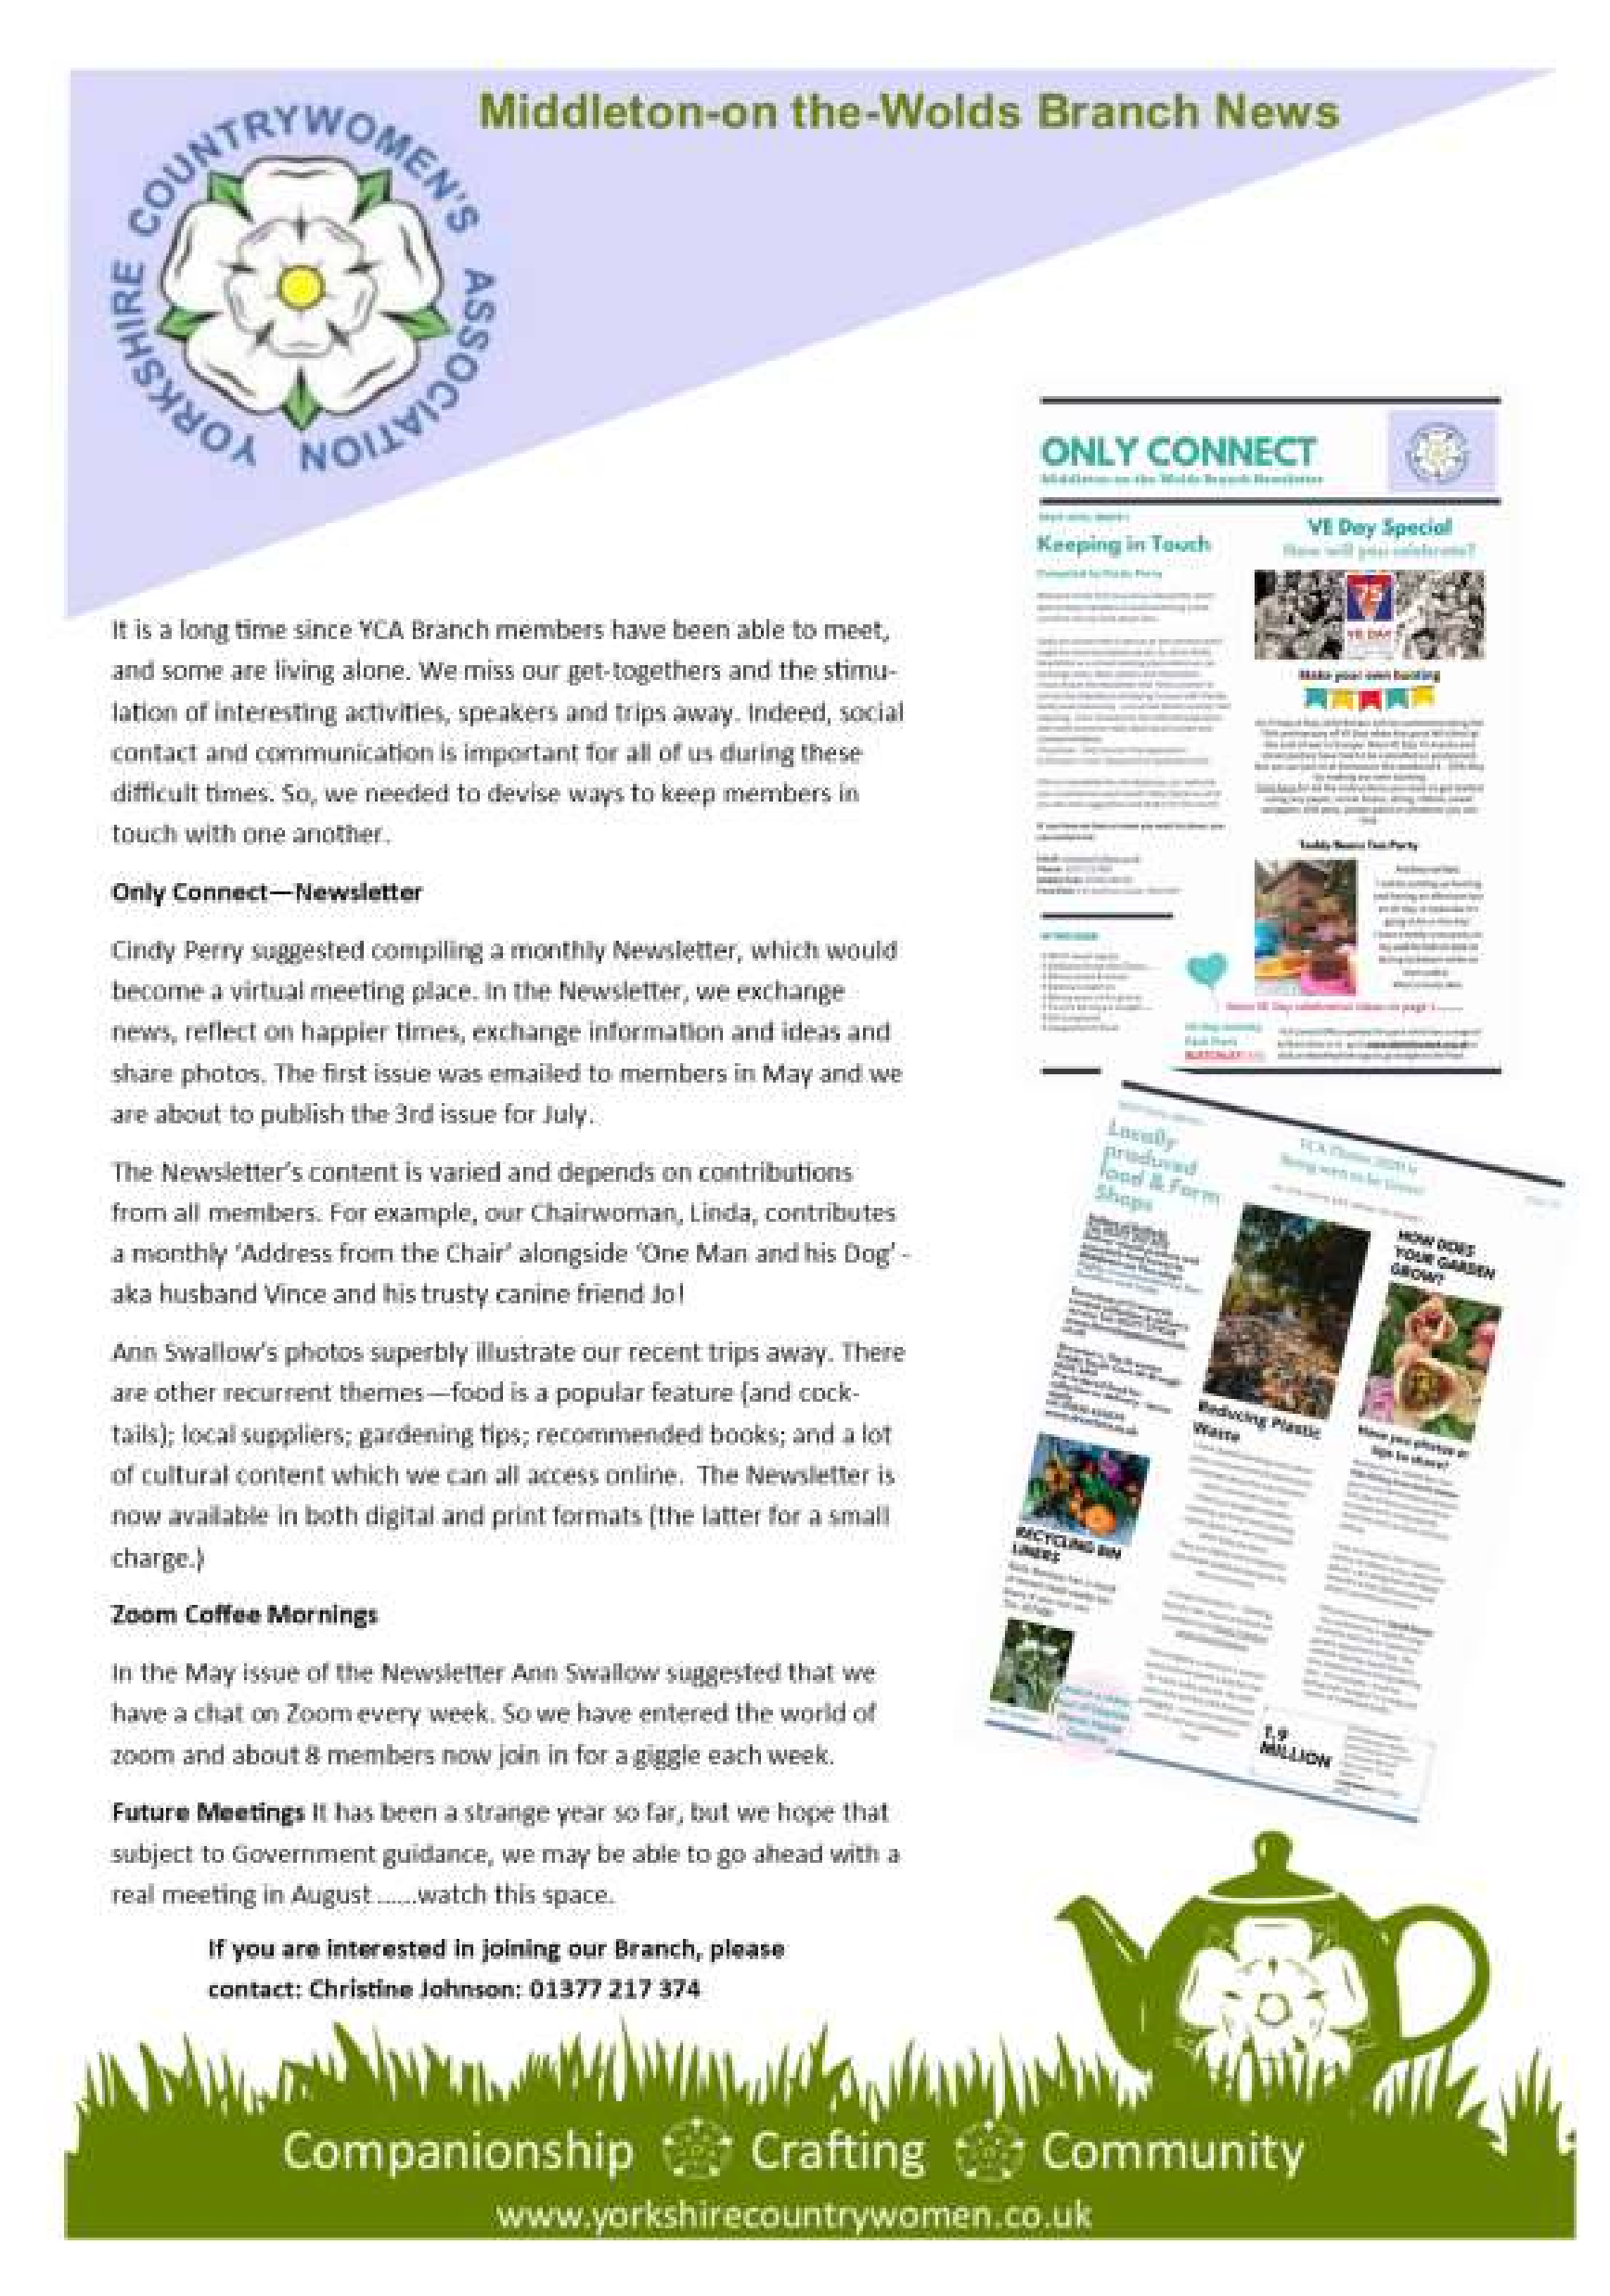

QUIZ PAGE
- What does Billingsgate Market in London specialise in?
- Which railway station was the first one in London 3 Who was the father of Solomon and second king of Israel?
- In which street is the Bank of England?
- How many squares are there on a traditional Snakes and Ladders board?
Which Actor appeared out of the top of Big Ben in the Olympic Closing 6
Ceremony?
- In which English city was Dick Turpin hanged?
- Which politician/rock star used to appear on stage in a coffin? 9 What model Aston Martin was originally used by James Bond?-
10 How old was Marilyn Monroe when she died?
Quiz set by Rowland Wooldridge
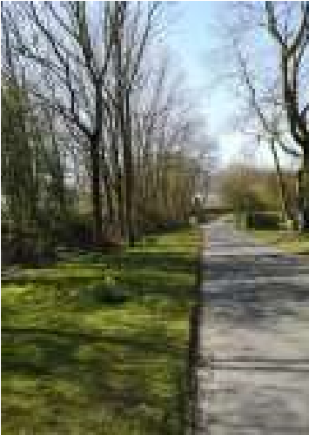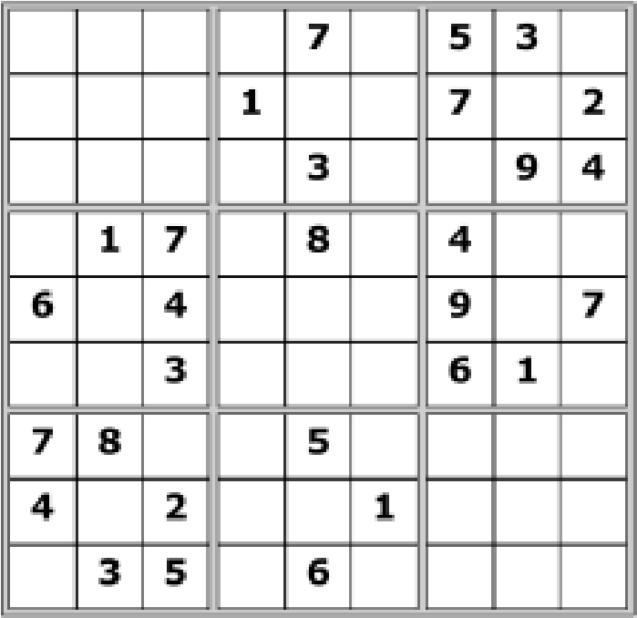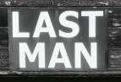

SAYINGS DINGBATS

SUDOKU

WHERE IN MIDDLETON?

All answers on page 15

A note from your vicar
July Customs – Rush Bearing and Swan Upping
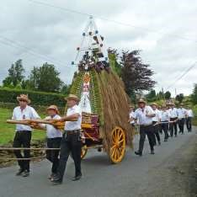
The beginning of July is marked in various parts of the country – especially the North, by Rush Bearing ceremonies.
When churches had mud floors rushes (along with hay and sweet smelling herbs) were scattered so as to keep the floor warm and dry. These would be renewed for special feast days such as Easter, Whitsun and the Patronal
Festival.
At one time there would be a procession of young girls, dressed in white carrying garlands and rushes, which they would leave in the church. This would be followed by a simple feast which everyone would join.
At its most popular the Rush Bearing
was a big event in many villages. The new rushes would be piled high on the specially decorated Rush Cart, drawn by fine Shire Horses it would be accompanied by Morris Dancers and children carrying garlands. In Saddleworth, the tradition was re-introduced and became a ‘Moriss Festival’.
The gifts to the church are called ‘bearings’ and many of them are in the form of intricately woven designs – often specific to different families. At Grasmere, the Rush Maidens carry symbolic rushes on a specially woven sheet and these ‘bearings’ are used to decorate the church.
The Sowerby Bridge Rushbearing was revived for the Queens’s Silver Jubilee in 1977 and has continued ever since. It takes place on the first weekend of September and the rush-cart is paraded through Sowerby, Ripponden, Triangle and Cotton Stones.
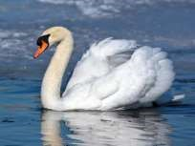
At the end of July Swan Upping takes place on the River Thames. Since the fifteenth century the Dyers’ and Vintners’ companies have the privilege of sharing ownership with the monarch of the swans on the River Thames. The annual Swan Upping begins on Southwark Bridge where the Royal Swanherd and the other two Swan Wardens meet and set off in skiffs in a procession, led by the Royal Boat. During the next few days they gather around 600 birds. The Dyers, traditionally, made one nick in the Swans beak, the Vintners made two, while all the Queens Swans were left unmarked, because she owns all the rest. Today the
swans are identified by leg rings and it is used as a yearly census of how well the Thames swans are breading. I think they no longer eat the swans, at least I hope that’s the case!
There is a nice pub at Bollington, Dunham Massey in Cheshire called ‘The Swan with Two Nicks’ which is rather fitting as they are the Vintner’s birds. This was a 16th Century pun, the word ‘nick’ also means ‘neck’. Humour has changed over the years! So, that’s why you can also see a few pubs called ‘The Swan with Two Necks’.

If there are any old traditions you remember, which took place in this area, please let me know. We might be able to reintroduce them.

Jane St Andrew’S church
By July, subject to various checks, we expect to be able to open the church for private prayer.
However one of the listed key holders will have to be asked to open up beforehand.

bereavement
Vivienne Knaggs (Hughes)

Many residents will still remember Vivienne Hughes as she was, who lived in The Paddocks and was a prominent member of the Parish Council for many years. Vivienne was involved in formalising the parish plan for Middleton but after the loss of her husband Bill, she moved away, yet kept in touch with many friends in the area. At the age of 75, she had a 'teenage romance' and married Keith Knaggs from North Yorkshire and the couple moved to Kirby Hill near Boroughbridge. Vivienne had a great lust for life and remained active, working with and supporting charities for older people. Vivienne passed away on May 23rd.
With the current restrictions on the use of churches, the funeral was limited to a few friends and family to witness a graveside burial with kind words read and some fond memories shared. It was really a perfect way to do this, in the sunshine with the birds singing and a perfect view of the 'white horse' carved into the hills of the North York Moors - and she would have approved. We will celebrate Viv's life again when conditions permit but for now, we send our sincere condolences to her husband Keith and all the wider family.

Madelaine and Ian Dewar
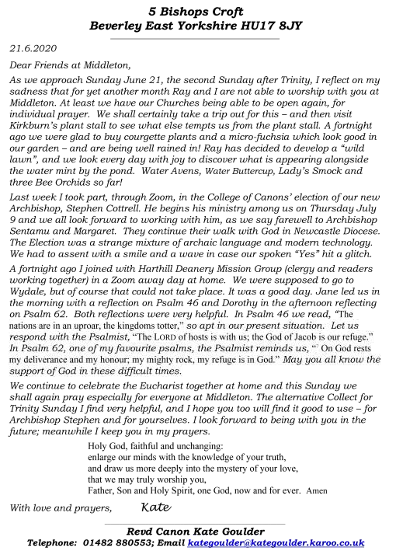
Messenger correspondence
Dear all,
Great news for family history researchers, you can now access some records on the National Archives for free! https://
www.nationalarchives.gov.uk/about/news/digital-downloads/
Unfortunately, due to software issues Find My Past will no longer be available to use from home. We apologise for any inconvenience this may cause. Ancestry will still be available.
Could I also take this opportunity to introduce myself, if any of you don't know me. I'm one of two local studies librarians for East Riding of Yorkshire libraries - and local studies is my passion. I try to organise talks and love to spread the word of what is going on in the area - and I am also particularly interested in buying publications relating to East Yorkshire.
If any of your groups ever produce material relating to the East Riding, could you please forward me the information - we do try to keep material on all the areas in the East Riding - and we have two specialist local studies libraries - one in Bridlington and one in Goole, plus every East Riding library has a section containing local history books and information.
I do hope we get to see you all, once this lockdown is over, but, until then, do stay safe.
Sarah
Sarah Hutchinson
Librarian – Bridlington central library, Stamford Bridge library and the Withernsea Centre
Tel: (01262) 672917 Direct dial (759) 203 Mobile 07885741453
Web: www.eastriding.gov.uk
Twitter: www.twitter.com/East_Riding
Facebook: www.facebook.com/eastridingcouncil

pilates
Middleton on the Wolds is a beautiful place to live. We are fortunate to have everything on our doorstep. There are beautiful walks around here, particularly the old railway track which is currently being made to look extremely beautiful by two members of the community.
I am qualified to talk about the benefits of exercise and what walking and other forms of exercise does for not only our physical health but also emotional health. My passion is Fitness
Pilates and I have been practising this for many years. I am a qualified Personal Trainer, GP Referral Consultant and Cancer Rehabilitation Through Exercise Consultant.
With Fitness Pilates and other disciplines such as Yoga there is always some mystique, but it is really quite simple. During the course of a 45 minute to an hour session you will actually exercise almost all of the muscles in your body. That means you will feel the benefits through hormonal changes in the body by increases in your serotonin and endorphin responses that you get through doing exercise. These make you feel good and if you continue with these types of exercise not only will you get muscular health, but you will get skeletal health such as a strong spine. We know through research that over 85% of people who suffer lower back issues benefit from doing appropriate exercise.
During these unprecedented times since lockdown, I have noticed quite an uptake in seeing people from all walks of life and ages exercising every day. This is so important for everybody.
Government health guidelines encourage the general public not to lead a sedentary lifestyle; this means we need to do two and a half hours exercise every week, this could be broken down into 5 half hours during the course of the week to get the major benefits that will support your health outlook. Walking is a major contribution to meeting your health needs.
During my Pilates classes I try to mix it up with a variety of exercises to condition the body, muscle, tendon, ligament, and heart health. The strength poses in Fitness Pilates and Yoga are particularly important and of benefit to you.
Breathing exercises, you do in Fitness Pilates are especially important for example, when you inhale through the nose, and feel that cold air in your nostrils you then fill up the lungs and the tummy. When you exhale this is where the magic happens because it totally relaxes the muscles all over your body, try it right now! At the same time, not only does the heart pump blood around the body but it takes in oxygen at the same time. The oxygenated blood flows around the body and does its magic. When you exercise to a slight perspiration a gaseous exchange takes place to the end of the blood vessels/capillaries to the end of the skin bringing nutrients to the skin and at the same time getting rid of toxins that have been stored in the body. Have you ever wondered why your skins looks so healthy when you have done even a little bit of exercise? It is for these reasons.
If you want any further information, or details of my classes please don’t hesitate to email me on rummogill@gmail.com or call me on 07789991962.
Stay safe and keep healthy

Gary Rummens
The wolds METHODIST CHURCH bainton
The chapel is still closed until further notice.
Hopefully there will be more positive news for you next month.

Parish council
The Parish Council are continuing to hold remote meetings; and have been advised by the Local Authority to continue in this manner whilst lockdown restrictions are in place. June has been a quite month for Parish Council Business however the great news that the Reading Rooms have been awarded a grant of £10,000 under the Small Business Grant Fund was well received by the Parish Council Members.
The Reading Rooms which are now being run by the Parish Council have recently been internally decorated, and the works are now complete; however they are in need of further investment and this grant will help to enable further works to be done. Hopefully once life is back to normal for us all; people will start to use the Reading Rooms for private functions or organised group meetings / clubs etc.
The Parish Council still have a vacancy for a Councillor, and anyone who feels they would like to apply and that they could help bring new ideas and support the needs of the village should contact the Parish Clerk either in writing or email. Alternatively please feel free to approach any member of the Parish Council for further information.
Looking forward to when Covid19 is beaten it has been discussed we should celebrate with some sort of a village party or village feast. Any suggestions would be much appreciated and anyone who would be willing to plan and arrange a celebration would be welcome to assist us with organising this.
John Eastwood

Middleton book group
The book group for June on Zoom (which we are all now getting used to using but missing the tea and cake !) featured two very different books , the first being the novel "Left Neglected " by Lisa Genova which is about a little known condition called left side neglect that can happen after a head injury. The person is completely unaware of anything on the left including their arm, leg or left side of their face. It can be permanent or may improve with rehabilitation .
The title is also a metaphor for all the things the lead character is neglecting in her busy life. Sarah, the main character, hits her head in a car accident (on her way to work in pouring rain whilst looking at her phone).
The story develops with Sarah having to reorganis her life and learn a new normal (something we are all having to do currently) and she comes to appreciate time in a different way and the little things in life (again something we can all do at the moment!)
I think everyone who read it really enjoyed it and those who hadn't said they would put it on their list as one to read .

The other book read by the group this month was "Mr Starlight " by Laurie Graham.
This is the showbiz story of an English Liberace character, as told by his older brother Cledwyn who has lived in his shadow most of his life.
Narrated with humour the story moves from the backstreets of Birmingham to America following Mr Starlight's (Sel) search for fame and fortune .
Despite the glitz and glamour Mr Starlight is quite a lonely and troubled soul. He is also the apple of his mother's eye and can do no wrong and poor Cled can do no right. We all agreed the mother is a real horror !
This is a book about families, secrets, fame, fortune and the lack of it. I think everyone thought it was a very amusing and enjoyable read, although it is, at times, quite sad .

Amanda

Next books for discussion:
June “66 Years a Cycle Tourist” by Clive Pratt
One of The Regeneration Trilogy books by Pat Barker

To find out more about the Book Group please contact Lyn on 219500 or lyndennis456@gmail.com

Middleton on the wolds ce ve school
Executive Headteacher: Mrs E Harros
Station Road, Middleton on the Wolds, Driffield YO25 9UQ
E-mail:middleton.primary@eastriding.gov.uk Tel: 01377 217323

We hope you are all continuing to keep safe and well. Middleton School has been open for the duration, including during the Easter holidays for all children of key workers. By the time you receive this newsletter we will have welcomed back our Reception, Year 1 and Year 6 children. We sincerely wish this could be the case for all of our year groups as we know it has now been a long time since the children were with us at school. All of the staff are hoping that things will gradually get back to some kind of normal and that we will be reunited as a whole school as soon as it is safe to do so.
Take care, be kind to yourselves and keep safe.

Clothing Collection
Our next clothing collection will be on Monday 28th September. Any unwanted clothes, coats, shoes, hats, scarves, handbag, belts, household linen, towels, curtains and soft toys can go in the collection. The heavier the collection, the more money that is raised for school, so please save all unwanted items for us. All bags need to be in the school car park by 9:00am on the morning of Monday 28th September.

Middleton Minis
We don’t anticipate our Middleton Minis group running again until at least the new academic year. Further details will be published in this newsletter nearer the time.

On-going Collections
On-going Collections – We collect used stamps, batteries, printer cartridges and mobile phones. These items may be left in a bag just inside the main door.
Thank you.
Middleton on the Wolds Nursery
At Middleton on the Wolds CE (VC) Primary School
Providing education for 2, 3 and 4 year olds Monday - Friday.
We accept the Government’s childcare vouchers for up to 30 hours of free provision for 3 year olds (conditions apply)
Additional sessions can be purchased for £13.50 per session for 3 year olds and £15.75 for 2 year olds.
Lunchtime sessions are £1.75 (free if children attend for the whole day) with the option to purchase a school meal for £2.40.
Children are welcome in the term after their 3rd birthday for funded places.
For further details, please contact: Sharon Stone
Email: middleton.primary@eastriding.gov.uk Tel: 01377 217323

End of Term
School closes on Friday 17th July and reopens at 08:40 am on Tuesday 8th September.

Local Birds & wildlife
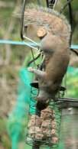
While most of us are spending a lot of time at home taking life more slowly than usual (sorry, I am not including families with young children in that!) outside birds are whizzing around frantically finding food for their newlyhatched nestlings, watching aghast as their fledglings bounce off branches and plummet to the ground and forage dutifully to feed the offspring who are now as big as them, perfectly capable of feeding themselves when the parents’ backs are turned but who beg noisily and pathetically when they return.

It was extremely noisy in our garden when our starling family moved out of the roof (though quieter for us in bed in
the early morning) and they were soon joined by a neighbouring nest-full of fledglings so the volume increased. It became difficult to walk up the garden without tripping over young robins and goldfinches abounded.

Joanna reported a busy spring too: “Baby birds are everywhere more hatching daily. Strange we haven’t seen any warblers in the garden this year. We have got blue tits and pigeons nesting in the garden - possibly tree sparrows. Greater spotted woodpeckers are coming back regularly; they must be feeding young now. Squirrels still attacking feeders.” She has sent two photos – “some of our regulars” – a stock dove (which don’t seem very common round here!) and a pair (should that be ‘brace’ or is that only when you are going to eat them?) of pheasants with the ubiquitous wood pigeon (and a discrete chaffinch). We are also finding our feeders speedily emptied – two squirrels, five jackdaws and a couple of rooks could be to blame!
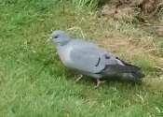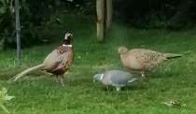

Pat on The Paddocks had an exciting time earlier in the month when they were sitting out in the garden “when a beautiful red kite started circling directly above very low down. I was afraid for our ducks although kites are not known to kill, who knows what they’ll do if very hungry. Anyway it was chased off by the rooks. However it came back and swooped down into the school yard and was once again chased off. It was overhead for some time. “I’ve never had such a close up view of a wild kite. Magnificent.” She also reported house martins nesting on her house - “They were nearly parting my hair while I stood outside watching them. Had to keep ducking!”

We have had an interesting experiment with beekeeping – well, to be honest it was the bees Ian-and-Barbara-keeping as they moved into our roof and trotted about above our heads buzzing quietly until we realised that our chimney needed fairly urgent repairs and that the builders were not happy about bees circling them menacingly. Luckily Beverley Beekeepers recommended Viking Pest Control, who try to find solutions other than killing the bees, and as these proved to be tree bumblebees he got them into a big plastic tub and took them off to be released in a wood. So if you need humane bee solutions get in touch and I’ll give you the details.

Otherwise please let me know any interesting wildlife sightings/events on 0777 192 7868 or email me lavenderbarbara97@gmail.com : I would love to hear from you!

Barbara
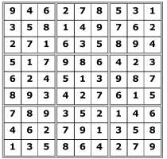
Quiz answers

Where in Middleton:

Beach hut at front of the
old garage
-

Black Yak

Cricket Club
-

Rec
ground

From AB Graphis
looking towards Station
Dingbats:

Water under the bridge

What goes up must
come down

Under the weather

Turn up for the books

Turn over a new leaf

Turn a blind eye

1

Fish

2

Euston

3

David

zz

Threadneedle Street

5

100 (10
10)
x

6

Timothy Spall

7

York

8

Screaming Lord Sutch

9

DB5 (1964)

10

36
years old

LOCAL HISTORY
THE VILLAGE HALL
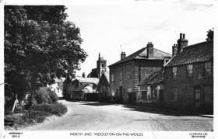
Doctor Ernest Clements and his wife Marion, with their four children born in the village, were no strangers to village activities and to celebrate their silver wedding anniversary decided to partly fund a purpose built village hall. Together they contributed £200, roughly the wage of a labourer for two years, with the remainder consisting of money raised by all the clubs in Middleton plus a loan of £370 from the Yorkshire Rural Community Council.
For years a room in the school had been used for events but this proved difficult when refreshments were served. By August 1935 it was agreed that construction work would be carried out by the Middleton firm of G T Eastwood and Son from a design by William Eastwood on a former market garden given by Charles Soanes (uncle of Tom) with legal work provided free of charge by Thomas Holtby of Driffield.
The new hall was opened by Major A. N Braithwaite, MP for the area and was described by the Driffield Times as “a well built structure comprising a large hall with ladies’ and gentlemen’s cloakrooms at the front and dressing rooms at the rear, also a kitchen and a fine floor for dancing.” The Rector, the reverend E J Wilson who was too ill to be at the opening donated a grand piano. The Rector died in 1937 but the fate of the piano remains a mystery. Maybe it was a casualty of war.
In the years since 1935 the hall has been used for countless social events and three can be recalled from momentous times.
On August Bank Holiday 1939 with the war looming a well attended dance was held with music provided by The Imperial Orchestra ( Driffield) with Reg Towse as MC which raised seven pounds and thirteen shillings for Village Hall funds.
In October 1941 Miss Doreen Marion Clements, daughter of Doctor and Mrs Clements, well known in tennis circles and a nurse in Beverley, married Flying Officer Stephen Todd, a Beverley Solicitor and held their wedding reception in theVillage Hall with 120 guests before departing for a honeymoon in Scotland.

On the 11th May 1945, three days after VE Day, the Drasdo Repertory Company presented Noel Coward’s comedy “Hay Fever” proceeds from which went to Mrs Anthony Eden’s fund for holidays for Working Girls’ Clubs. Mrs Eden was the first wife of the ill-fated future Prime Minister.
The hall had been commandeered by the army during the war and derequisitioned in May 1945. In the years following Pam Linford remembers “ Wedding receptions, village parties, dances (usually to the accompaniment of Billy Thompson and his Rhyhm Aces) whist drives, beetle drives, W I meetings, endless jumble sales for village fund raising or charities, The Produce Show (huge interest in that) weekly cinema show (very well attended) pantomimes, plays (amateur dramatic societies) and there were also occasional talks.” Billy Thompson, originally from Northumberland, married Audrey Burnett and also maintained the village green for many years.
In the 1980s and again in 2006 work was done to bring the facilities up to date and maintain a healthy use of the premises in changing times.
Geoff Wisher

Village hall news
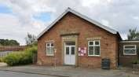
The Village Hall remains closed at the moment due, of course, to COVID 19. Tina, who cleans the hall for us on a regular basis, is taking the opportunity to spring clean areas that she doesn’t normally have time for. One of the things that you will notice is that she has shampooed all the chairs, even managing to get rid of the wine stains on some (now, I wonder how they got there!).
We are also hoping to get the flat roof replaced in the next few weeks as there was a bad leak during the winter. There is hope that we may be awarded a grant for part of the cost as we applied for one in January but the work will be able to go ahead regardless because, like the Reading Rooms, we are delighted that the Village Hall has also qualified for a £10,000 Small Business Grant from East Riding of Yorkshire Council.
Once the government advice changes we will be able to re-open for the regular groups who hire the hall and for private functions, putting into place any safety measures that are recommended. We will let you know how things stand in the August issue of the Messenger.

The Village Hall Committee
Advertising Feature

Advertisement
Advertising Feature

 | LOCAL CONTACTS Bell Ringing Chris Atkin |  | 217285
 | Book Group/Middleton Movers | Lyn Dennis | 219500
 | Bowls Club | Rob Bradley | 217435
 | Country Women’s Association | Christine Johnson | 217374
 | First Responders | Chris Brent | 219469
 | Line Dancing | Pat Pottage | 217516
 | Methodist Chapel | Miss P Hodgson | 217426
 | Middleton Messenger | Mike Kelly | 07713 620912
 |  | Lyn Dennis | 219500
 |  | Tina Walker | 217242
 | Middleton Womblers | Andrew Naylor | 219072
 | Parish Clerk | Sandra Morrison | 01262 470496
 | Reading Rooms | Kath Bentley | 217456
 | Recreation Club | Dave Newlove | 07901 833784
 | St Andrew’s Church | Rev Jane Anderson | 219471
 | St Andrew’s Church Warden | Roger Lowe | 217656
 | Table Tennis | Louise Newlove | 217801
 | Village Hall Lyn Dennis |  | 219500
ADVERTISING COSTS for the Messenger
Rates Month Year

Whole Page £25 £150

1/2 Page £15 £100
1/3 Page £10 £60

